________________________________________________________
PEOPLE’S CRAFT TRAINING CENTER(PCTC)
KONDAM-KARIYANDAL, VIA - NAYUDUMANGALAM-606802. TIRUVANNALAI DISTRICT.
PH: +91 4175 246464 TELEFAX: + 914175 246215 EMAIL: pctc1991@sancharnet.in

As we enter into our 16th year of existence, the past has given us lots clues to live the present and plan for the future. It has been a year of enriched experience and given us certain directions to our planning process.

Community based Rehabilitation program:
368 Children were part of the services of the educational intervention of the total 1666 people with disability. 20 children were regularly attending the day care centre at Kariyandal and Nookambadi. 55 children in Kariyandal and 54 in Nookambadi regularly present with their parents for weekly or monthly intervention depending upon the plan given to them. This included 23 children attending early intervention clinic and 11 slow learners. 18 different kinds of assistive devices were provided from the workshop and 22 were repaired. 8 children received therapy equipments. 20 of the equipments supplied already were repaired. 593 rehab interventions received from Government Rehabilitation Department, which includes livelihood support, assistive devices, scholarship for school children and so on.

We have formed 5 new self help groups, which has taken the total to 54. Except 6 groups none of the other groups were not linked for credit assistance, as we were waiting for support from Nationalised banks. This has prompted us to go in for linkage from private banks. Next year more of these groups will be linked. A three day residential training was organised for 75 children with special needs on activities of daily living. Two days skill training was given to 50 children. This would help us in identifying the skills in them and later on train them in the same, so that it can become their occupation.

In the prevocational training unit we were able to provide job opportunities for 4 adolescent persons with disability. Thanks to our friends in Switzerland for the regular order of smell bags.

With periodical training to the staff they were enabled to take charge independently. Vermi-compost has been identified as a new trade for Vocational training. There are plans to integrate horticulture program along with it.

Remarkable developments can be seen from children attending early intervention program. Parents showed interest and involvement in monthly savings. This entitles them to avail matching grant from PCTC for Family development support to start income generation activity. Family development support has motivated parents for better cooperation in the rehabilitation process.

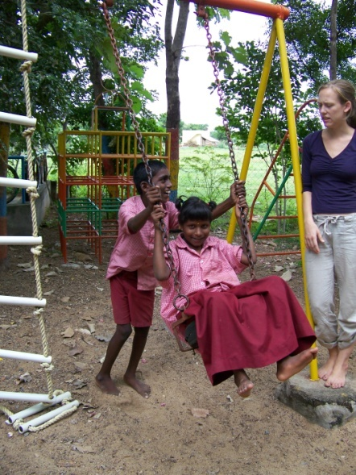

The following are some of the difficulties we encountered during last year. Continuous turnover of staff, limited transport accessibility to the children with disability affects the program to certain extent.

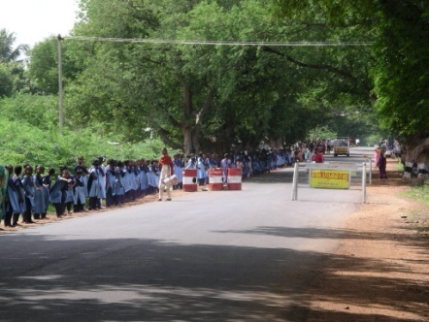
Human chain by School children for the social integration of children with special needs.

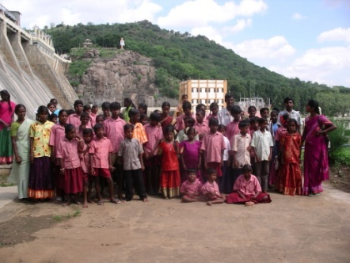
Children with special needs had a day out to Sathanoor Dam
Community Health Program:
We continued with our regular activities in the community health program like dispensary in the base unit with facility for massaging, treatment for 135 children with Disability, treatment for 8 people living with HIV, monthly community health promotional camps with herbal exhibitions in the villages.

We have also involved ourselves with Junior Red Cross program of Tiruvannamalai District both at District and regional level. School children from 150 Schools participated in the Aids awareness Essay competition. More than 1000 children participated in the program. Prizes were awarded at Taluk and District level.

The leaders of the self help groups received health education classes once a month. In collaboration with TNVHA TB Day was observed in which 50 NGOs had participated. We were also giving technical assistance to PET NGO at Chengam to develop a community Health program using herbal medicine by training 10 of their health workers. Our monthly support visits helped them to develop the program.

Supply of curry leaf powder for nutritional support to the children in two blocks in Integrated Child development services continued this year too. As part of our networking program we continue to be the District Resource Center for health promotion and district Facilitation Center for Indian Systems of Medicine and Disability.

Though this system of Medicine is born in this soil, due to colonisation and commercialization people got alienated from this system of medicine. Our effort during the last few years has not given the expected results. We have changed the strategy and going to work through the students in the villages.

Women Development Program:
We strongly feel the need to consolidate the program and in this process the women leaders should play a major role in assuming the responsibility to run the show of maintaining the women federation activities. It is also decided to register the federation as an independent body. As on date 1204 women have registered as life members and are entitled to life cover, educational assistance for children, credit assistance whenever they require and hand holding support for microenterprise creation. From the insurance cover of Rs:230,000 was given to 7 members who died during last year. Rs:234,000 educational assistance was given to the children of life members.

This year People’s Festival (Makkal Thiruvizha) was celebrated outside our campus in Mallavadi in which more than 4000 people have participated. Every year this festival gets its new dimension. Exhibitions, competitions and cultural events marked the occasion.

We have a total number of 684 women self help groups, 42 youth groups and 54 special self help groups for people with disability. Where ever people are finding hard to access the bank, we have utilised the services of post offices to open the 11 SHG accounts. Now our groups have a total savings of 16 million rupees. During the reporting period there was difficulty to link the groups for credit assistance from Nationalised banks. We took effort to identify a private bank and the process is completed for credit assistance in April 2008 for 8 groups. This process will continue till the requirement is fulfilled. So far 410 groups are credit linked.

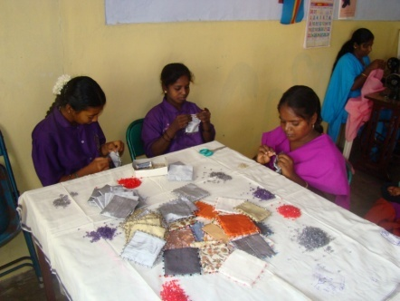
Smell bags being prepared

Though we have so many groups micro enterprise promotion is not taking place as we expected. So during the coming year our concentration will be more in this regard with the support of NABARD. Leadership and management training was given the leaders of 9 SHGS. Members from 5 groups were trained about the functioning of SHGS.

Our concentration was also to make the Panchayat level Federation (PLF) a viable entity, so that it can play the role of maintaining all the groups in a Panchayat and involve the members to play a proactive role in their village development. 11 more PLF have received the seed money, which takes the total to 28 out of 47 PLFs.

The FARM:
The Farming activity is getting more organised these days. It is very difficult to get farm labourers. We change the strategy for less labour intensive activity. The different kinds trees planted in the Farm slowly giving its first yield these days. We explore the possibility to sell our organic products through an organised outlet.

Volunteers:
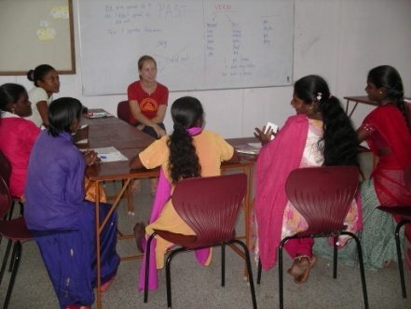
We had a stream of volunteers during this year. Caroline from the School of Tourism in Samedan did feasibility study on Social tourism. Lila and Paskal had actively participated in the day care center for children with disability. Marina who stayed with us for almost a year is planning to come back after a break of three months and to involve in new micro enterprise program- wooden toys.

Tsunami Rehabilitation program:
The Tsunami Rehabilitation program in North Mettustreet of Erukattancherry is going on for the third consecutive year. We were able to complete 69 toilets. Now all the households have a toilet. The livelihood support program for the self help groups did not make much progress as we find it hard to bring them into a system. Still the hangover of Tsunami rehabilitation is on them. Thanks to Demains for the support to Tree NGO in the coming year so that the follow up support is ensured for the next two years, so that all that has been initiated in that village will be sustained. The Day care center building for the Children with special needs will be completed in the coming year by the end of June.

Computer School:
Our sincere effort to bring in resources to rural areas in the form of a computer school, for the benefit of the local youth and to our disappointment we were not able to get enough students. We have looked into the reasons and reorganising the program, hoping that it should give its dividend in the coming year.

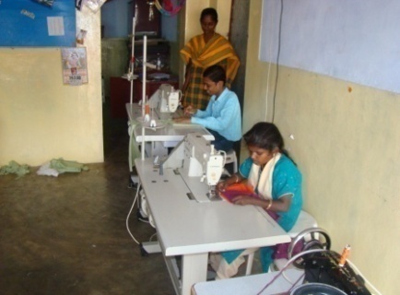
Family life Education Program:
2 batches of 6 months family life education program was conducted in Kariayandal and in Nookambadi. A toal number of 35 girls benefitted from this program.

The plans...
We have been always thinking of starting small employment generation unit, where by the local people can be employed, which will prevent migration of people from our area to other cities, which is the cause of other Social and health problems in the family and in the community.

During the course of the year we had an opportunity to explore the possibility for initiating a training unit for wooden toys. The proposed training will commence in the month of June and hoping to train 10 persons and after the training each one of the participant will be encouraged and supported to establish their own production unit and we will have marketing tie up with them. We have started the preparatory work for establishing this unit.
English Lessons for Computer school students and staff of PCTC
Due to the sudden withdrawal of Community Based Rehabilitation workers last year, we were planning to replace them with cluster coordinators, who can cover a wider area and be full timers. As we were not able to find suitable candidates, the gap in the program was very
visible during the year. This has prompted us to work out a new

Pre vocational unit new Electric
Sewing machine
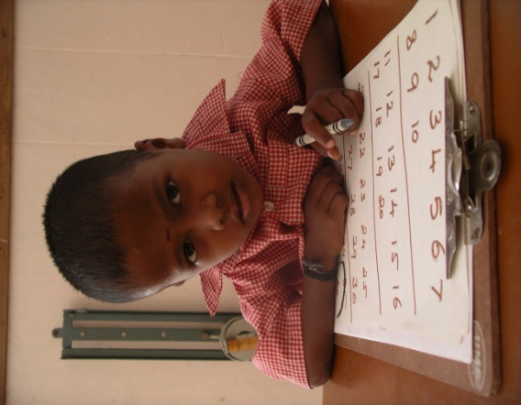
strategy. The process is on to appoint 20 Community Based Rehabilitation workers this year. They will play the link role between the community and the centre. At the same time help us to establish students’ club in these villages. From our past experience any activity among the students has lasting impact. So we decided to expand our village base from people with disability, women and to the children now through an organised program.

Urbanisation is affecting the villages to a greater extent and there is a tendency in the villages after the basic education youth tend to leave the village which affects their life in the longer run. We will work in this front through youth Self help groups.

Two our senior staff left the organisation who were with us from the beginning. We took this opportunity to reorganise our structure in a different way and have amalgamated our rehabilitation workshop with Rehabilitation department. We are looking for volunteers to make plans and organise our Organic farm.

Financial status of PCTC during 2007-2008

Thanks
We would like to make a special mention about Enfants du Monde, France for all their assistance and support from the beginning till the end of 2007. We remember all the friends who were part of EDMF and were instrumental in supporting all the new initiatives of PCTC. We will sustain whatever has been initiated in the past with your support.

Swiss Friends had been always instrumental in guiding and bringing in new support for all the developments taking place at PCTC. All our friends and supporters in Europe, The District administration of Tiruvannmalai, Department of Rehabilitation, District rural development agency, NABARD and all the bankers deserve our appreciation for their kind cooperation.

With grateful heart I present this report to you, as your heart is always with us all along the year. It is continuously pumping in “support, encouragement and guidance”. But for you, something would have been missing in all that we have been doing during past years. We commit to continue this task.

Murali from our Mazhalai Special School
for Children with special needs
is ready for mainstreaming

Constructions:
We are adding one more Floor at Nookambadi PCTC campus to have more space for Rehabilitation and other activities. In the coming year the compound wall on northern side, a new toilet complex and cemented road inside Kariyandal PCTC campus will be completed
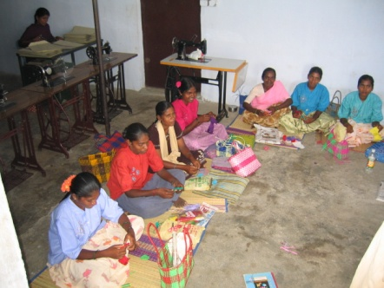
Family life education for teenage girls

People’s Craft Training Center (PCTC) is located 16 KM from Tiruvannamalai on the way to Vellore. Bus Stop: KONDAM

PEOPLE’S CRAFT TRAINING CENTER(PCTC)
KONDAM-KARIYANDAL,
VIA - NAYUDUMANGALAM-606802. TIRUVANNALAI DISTRICT.
PH: +91 4175 246464
TELEFAX: + 914175 246215
EMAIL: pctc1991@sancharnet.in
Website: www.pctcability.org

